

**Product Dissection for *Flipkart***

**Contribution - Individual**

**Author - Tanmay Dhar**

**Company Overview:**

Flipkart, founded in 2007 by Sachin Bansal and Binny Bansal, is one of India's leading e-commerce company, headquartered in Bangalore, Karnataka. Flipkart has a registered customer base of over 100 million and offering over 80 million products across 80+ categories. This Indian e-commerce store has brought a revolution in the Indian e-retail industry.

**Product Dissection and Real-World Problems Solved by *Flipkart*:**

Flipkart, a Indian e-commerce platform, has effectively addressed real-world challenges through its innovative product offerings. Flipkart offers a wide range of products, including electronics, fashion, home essentials, groceries, and lifestyle products. Let's dissect some of the key aspects of Flipkart's operations and the problems it has solved:

**Online Shopping Platform:** Flipkart provides a user-friendly online platform that enables customers to browse and purchase a wide range of products, from electronics to fashion, groceries, and more. This platform addresses several problems:

**Convenience:** Flipkart offers customers the convenience of shopping from the comfort of their homes, eliminating the need for physical store visits.

**Accessibility:** It brings products from various brands and sellers to customers in even remote areas of India, thereby addressing the issue of limited access to quality products.

**Price Comparison:** Flipkart allows customers to compare prices and read reviews, empowering them to make informed purchasing decisions.

**Supply Chain and Logistics:** Flipkart has invested heavily in building a robust supply chain and logistics network. This addresses challenges related to efficient product delivery, including last-mile delivery in India's diverse geography.

**Efficient Delivery:** Flipkart's logistics network ensures timely and efficient delivery, reducing the wait time for customers.

**Cash-on-Delivery:** In a market where many customers prefer cash transactions, Flipkart pioneered cash-on-delivery (COD) options, increasing trust and convenience.

**Payment Solutions:** Flipkart offers various payment solutions, including digital wallets and EMI options, to cater to diverse customer needs.

**Financial Inclusion:** By providing EMI options, Flipkart makes high-value products more affordable, addressing financial inclusion issues.

**Digital Payments:** It promotes the adoption of digital payments, contributing to the digitization of the economy.

**Marketplace and Seller Ecosystem:** Flipkart has created a marketplace that allows third-party sellers to list their products, boosting entrepreneurship and addressing employment issues.

**Job Creation:** The platform has created job opportunities for sellers, delivery personnel, and customer support staff.

**Entrepreneurship:** It has enabled many small and medium-sized businesses to reach a wider audience and grow their operations.

**Technology and Innovation:** Flipkart continually invests in technology and innovation to enhance user experience and solve logistical challenges.

**AI and Machine Learning:** These technologies are used for product recommendations, fraud detection, and supply chain optimization.

**Sustainability:** Flipkart is working on sustainable packaging and reducing its environmental footprint, addressing ecological concerns.

***Conclusion:***

Flipkart has significantly impacted India's e-commerce landscape and addressed various real-world problems through its innovative products and services. It has revolutionized the way Indians shop, offering convenience, accessibility, and affordability. Moreover, Flipkart's contribution to job creation, entrepreneurship, and the digitization of payments has had a positive socio-economic impact.

However, challenges remain, including competition from other e-commerce giants and addressing environmental sustainability concerns. Nevertheless, Flipkart's commitment to innovation and customer-centric solutions positions it as a key player in India's evolving e-commerce ecosystem, continually striving to solve real-world problems and improve the lives of its customers.

**Case Study: Real-World Problems and Flipkart's Innovative Solutions**

Flipkart, a leading e-commerce platform in India, has not only revolutionized the way we like but has also addressed significant real-world challenges through its innovative features. By identifying user needs and leveraging technology, Flipkart has positioned itself as a solution-driven platform that fosters people needs, interests and easy access. Here is some problems I discuss:

Problem 1: Limited Access to Quality Products

* Problem: In a vast and diverse country like India, access to quality products was limited, especially in rural areas.
* Approach: Flipkart leveraged its online platform to bring together a wide range of products from various brands and sellers, making them accessible to customers across the country.
* Impact: It addressed the issue of limited access to quality products, leveling the playing field for consumers in both urban and rural areas.

Problem 2: Inefficient Supply Chain and Last-Mile Delivery

* Problem: India's complex geography posed challenges for efficient product delivery, particularly in remote areas.
* Approach: Flipkart invested heavily in building a robust supply chain and logistics network, enabling efficient product deliveries, including pioneering cash-on-delivery (COD) options.
* Impact: Customers experienced faster, more reliable deliveries, and the COD option increased trust and convenience, especially among those who preferred cash transactions.

Problem 3: Financial Inclusion

* Problem: Many consumers found it challenging to afford high-value products due to financial constraints.
* Approach: Flipkart introduced EMI options, allowing customers to purchase expensive items in installments, thus promoting financial inclusion.
* Impact: It made high-value products more affordable, expanding the customer base and addressing the issue of affordability.

Problem 4: Job Creation and Entrepreneurship

* Problem: Unemployment and underemployment were significant challenges in India.
* Approach: Flipkart created a marketplace where third-party sellers could list their products, thereby promoting entrepreneurship and generating job opportunities for sellers, delivery personnel, and customer support staff.
* Impact: The platform has contributed to job creation and the growth of small and medium-sized businesses, fostering entrepreneurship and economic development.

Problem 5: Technological Advancements and Sustainability

* Problem: Traditional retail operations were often inefficient, and environmental concerns were growing.
* Approach: Flipkart heavily invested in technology, using AI and machine learning for product recommendations, fraud detection, and supply chain optimization. Additionally, it initiated efforts to reduce its environmental footprint, including sustainable packaging.
* Impact: The adoption of technology improved operational efficiency and customer experience, while sustainability initiatives demonstrated a commitment to environmental responsibility.

***Conclusion:***

Flipkart's journey from a startup to India's leading e-commerce giant is a testament to its ability to solve real-world problems through innovation and customer-centric solutions. By addressing issues related to accessibility, delivery, affordability, employment, and sustainability, Flipkart has not only transformed the e-commerce landscape in India but also contributed to socio-economic development in the country. Its approach to solving these problems serves as an inspiring case study of how businesses can have a positive impact on society while achieving significant growth and success in a competitive market.

**Top Features of *Flipkart*:**

Flipkart offers a wide range of features and services to its customers and sellers. Here are some of the top features of Flipkart:

**Product Search and Browsing:** Users can easily search for products and browse through a vast catalog of items across categories such as electronics, fashion, home appliances, and more.

**User Accounts:** Customers can create accounts to save their preferences, track orders, and manage their addresses and payment methods.

**Product Reviews and Ratings:** Flipkart allows users to read and write product reviews and rate items, helping others make informed purchase decisions.

**Wishlist:** Users can add products to their Wishlist for future reference or purchase.

**Secure Payment Options:** Flipkart provides multiple payment options, including credit/debit cards, digital wallets, UPI, and cash on delivery (COD).

**EMI and Financing:** Customers can avail themselves of EMI options and financing for high-value purchases, promoting affordability.

**Order Tracking:** Customers can track the status of their orders in real-time, from processing to shipping and delivery.

**Seller Dashboard:** For sellers, there is a dedicated dashboard to manage product listings, inventory, pricing, and order fulfillment.

**Customer Support:** Flipkart offers customer support through chat, email, and phone to assist with inquiries, returns, and concerns.

**Deals and Discounts:** Users can access various deals, discounts, and offers on products, especially during festive seasons and sales events.

**Mobile App:** Flipkart has a user-friendly mobile app for convenient shopping on smartphones and tablets.

**Schema Description:**

To create a schema description for Flipkart, let's outline the primary entities and their attributes:

**User Entity:**

* User ID (Primary Key)
* Username
* Email
* Password
* Phone Number

**Product Entity:**

* Product ID (Primary Key)
* Name
* Description
* Category
* Price
* Average Rating

**Order Entity:**

* Order ID (Primary Key)
* User ID (Foreign Key)
* Order Date
* Status (e.g., Processing, Shipped, Delivered)

**Payment Entity:**

* Payment ID (Primary Key)
* Order ID (Foreign Key)
* Payment Date
* Payment Method (e.g., Credit Card, COD, Wallet)

**Review Entity:**

* Review ID (Primary Key)
* User ID (Foreign Key)
* Product ID (Foreign Key)
* Rating
* Review Text
* Review Date

**Wishlist Entity:**

* Wishlist ID (Primary Key)
* User ID (Foreign Key)
* Product ID (Foreign Key)
* Date Added

**Seller Entity:**

* Seller ID (Primary Key)
* Seller Name
* Seller Email
* Seller Phone Number

**Inventory Entity:**

* Inventory ID (Primary Key)
* Seller ID (Foreign Key)
* Product ID (Foreign Key)
* Quantity
* Price

**ER Diagram:**

Here's a simplified ER (Entity-Relationship) diagram for Flipkart:

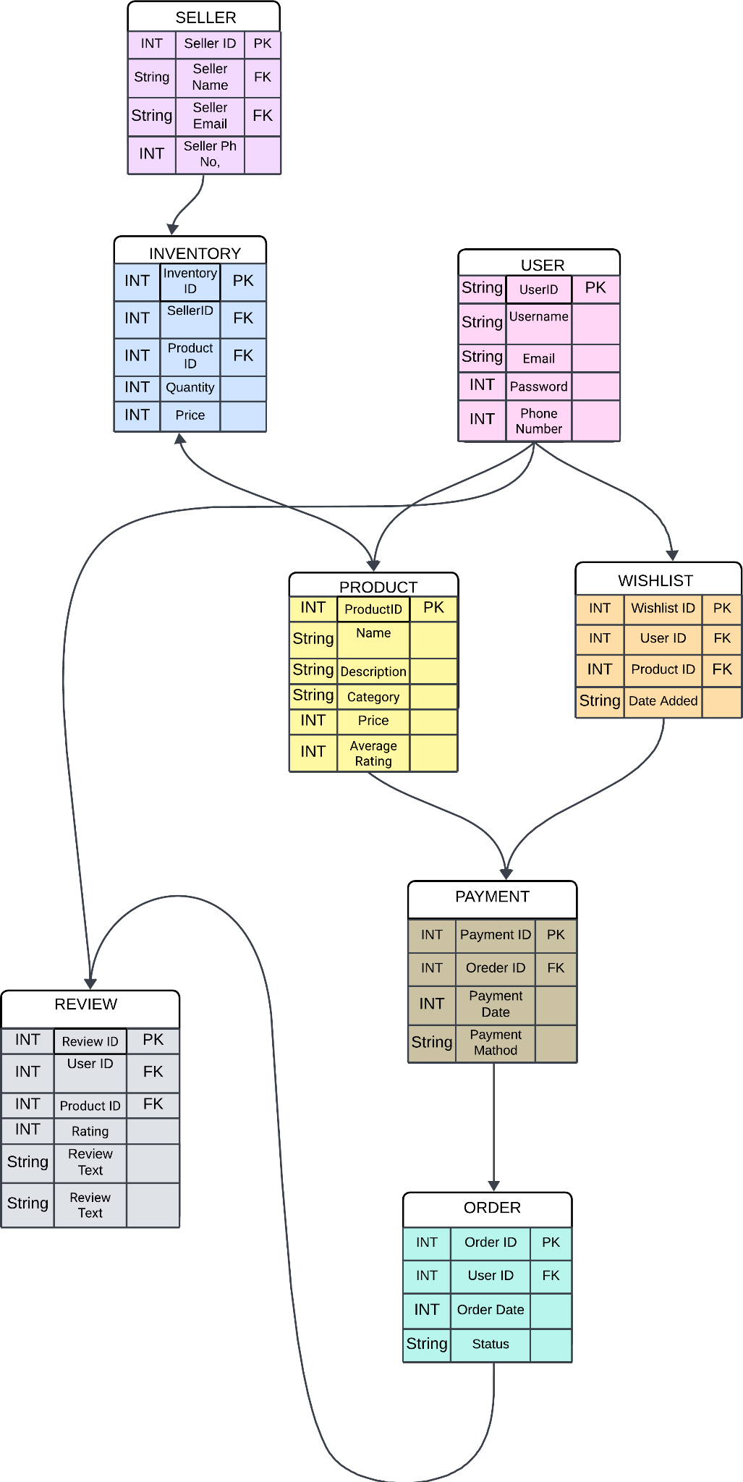

In this diagram:

* User, Product, Seller, Order, Payment, Review, and Wishlist are the entities.
* The lines connecting the entities represent relationships between them.
* User ID, Product ID, Seller ID, Order ID, Payment ID, and Review ID are the primary keys of their respective entities.

Foreign keys (e.g., User ID, Product ID) establish relationships between entities.

This ER diagram provides a high-level overview of how Flipkart's data is structured and how different entities relate to each other in the system, facilitating the management of user accounts, products, orders, payments, reviews, and more within the platform. Note that the actual database schema would likely be more complex to accommodate additional features and optimization.

***Conclusion:***

Flipkart, through its user-friendly interface and a wide array of features, has become a prominent player in the e-commerce industry. Its schema and ER diagram provide a structured way to manage user data, product information, orders, and more, allowing for efficient operations and a seamless user experience. Flipkart's commitment to user satisfaction, affordability, and accessibility has contributed to its success and position as a leading e-commerce platform in India, continually evolving to meet customer needs.

**Technical Document :**

[Technical Document](https://docs.google.com/document/d/1PULjs23S_FwNfQTbLPQR6j1tiv86jJfNMJm2ZTa-mgA/edit?usp=drive_link)